PART B: Steps for migration of firebase database for new client/institute

Notes:
- Each new Institute/Client will receive LMS website as www.lms_xxxx.anshumantech.org where xxxx = <institute name>)
- LMS software package uses Firebase(Google) for storing real-time database/pdf/video links etc. on ‘pay as you go’ basis being variable storage, while front end GUI is written in FLUTTER & DART. This version of LMS(ver1.0) is hosted on VERCEL platform(paid version), while in later version code is hosted on GitHub with storage limit of 1GB, Both use The firebase storage which is free up to 5GB, beyond which it becomes paid (BLAZE- pay as you go) Contact factory in case above limits are exceeded during your usage to change mode of subscription
- Following procedure in part B sets up LMS code(ver2.0) in new repository(LMS_Anshuman) in GitHub using firebase project (LMS-ANS) APIs dated 16/10/16 connected with email (sales@anshumantech.net) for authentication & payment ref & same email can be used for many such LMS projects delivered to different institutes.

- Changes in Code files:
Sr No. | File Name | From Line no. | To Line no. | Description
1 | lib/firebase_options.dart | 49 | 78 | Changes in API keys, Project IDs etc.
2 | Firebase.json | 1 | 1 | Changes in API keys, Project IDs etc.
Don’t directly change above 2 files instead follow below step by step procedure that does change above 2 files

- Components used and need to be configured in firebase:
- Storage
- Realtime Dashboard
- Firestore
- Authentication
- Analytics Dashboard

Step 1: Create new firebase project:-
- Go to console.firebase.google.com
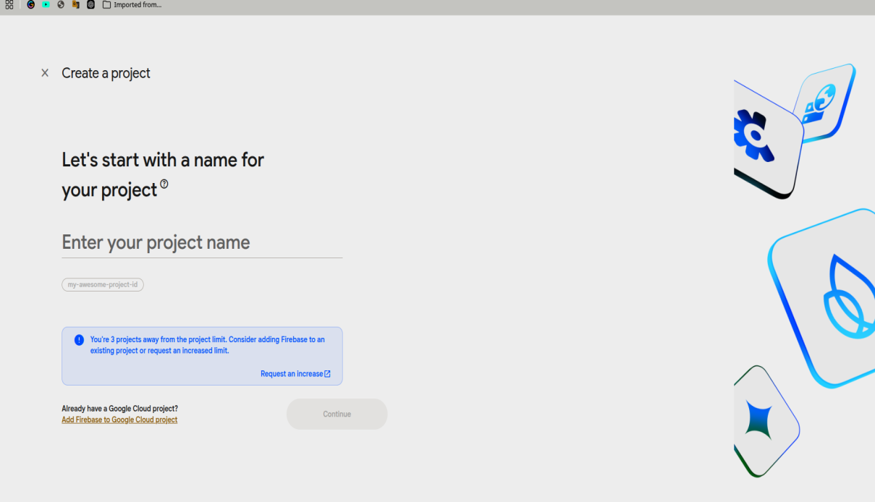
- Enter project name and click on continue
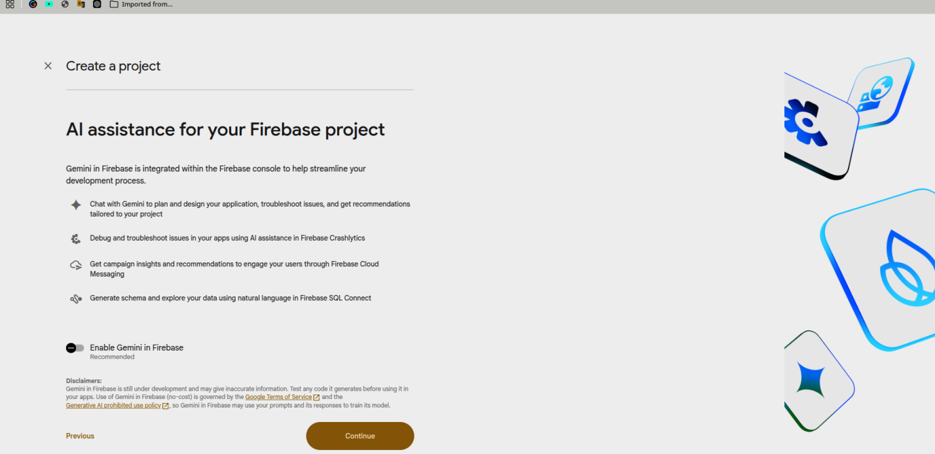

- Disable Gemini in firebase & click on continue.
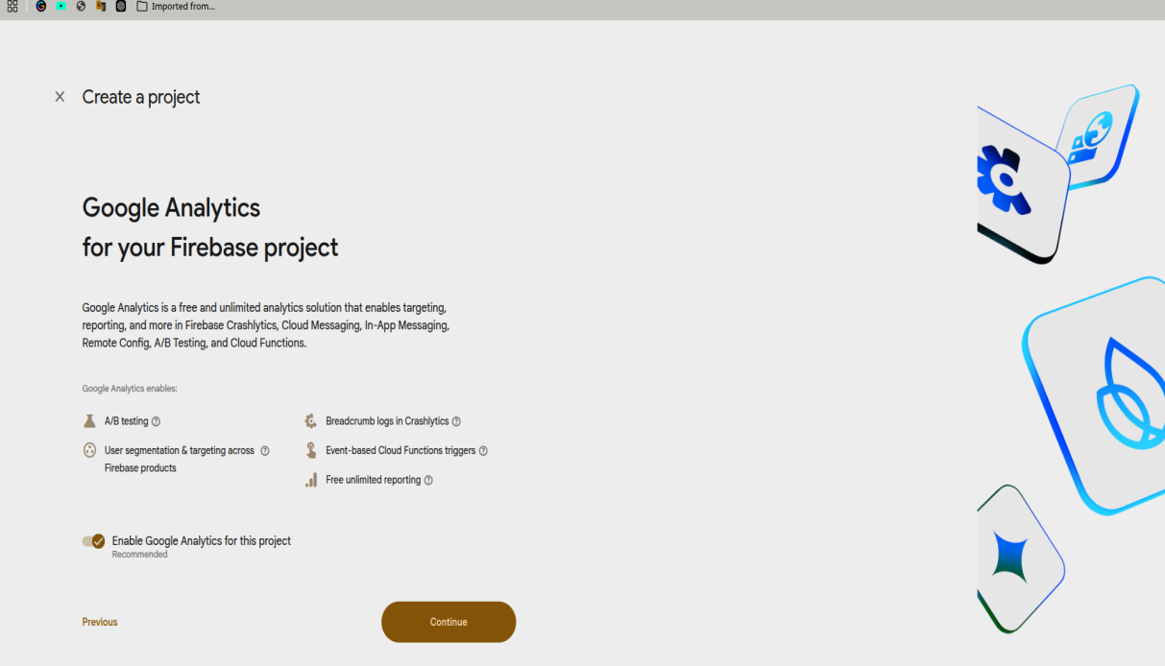
- Keep Google Analytics for this project enabled and click on continue
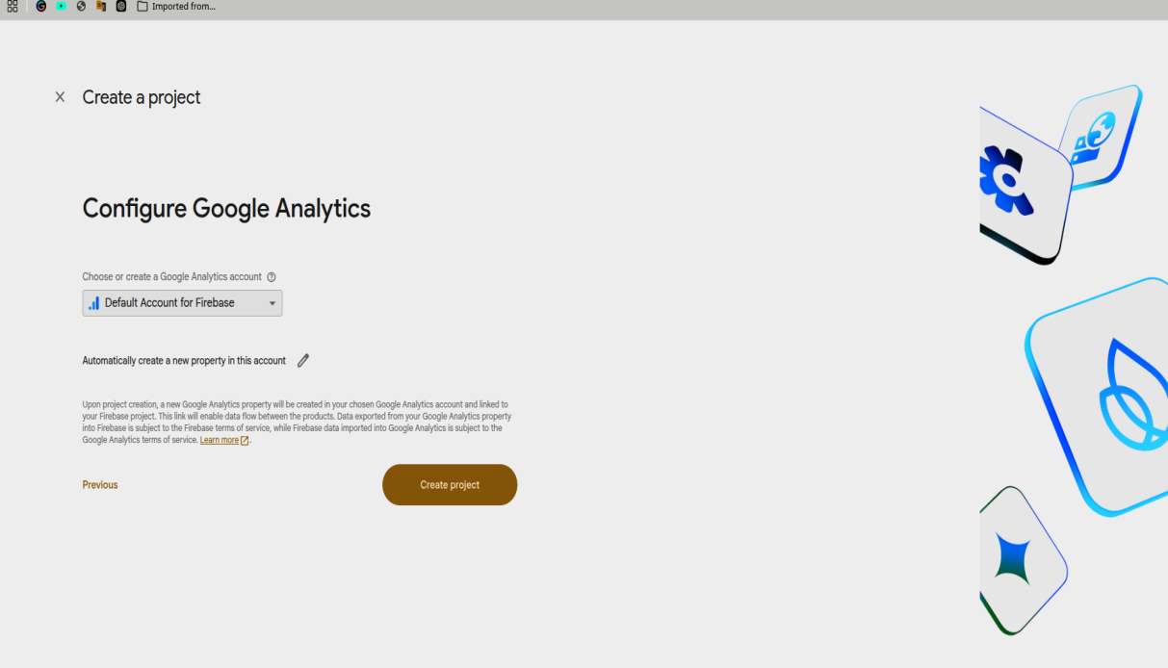
- Now click on Create project
- New project is ready.

Step 2: Configure project settings:-
Pin below settings in project for configuration and then do as stated below that
- Storage
- Realtime Dashboard
- Firestore
- Authentication
- Analytics Dashboard

- Set Sign-in method for Authentication as Email/Password enabled
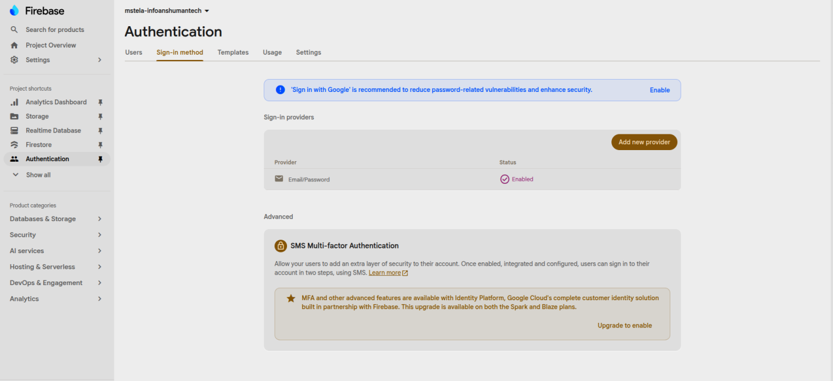
- Set Rules for Realtime Dashboard as
{
“rules”: {
“.read”: “auth !=null”,
“.write”: “auth !=null”
}
}
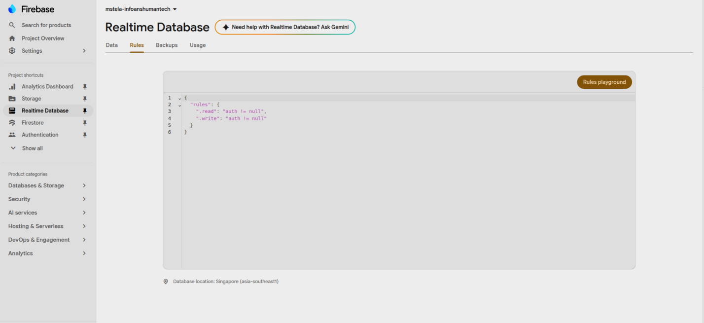

- Set Rules for Storage as per below screenshot
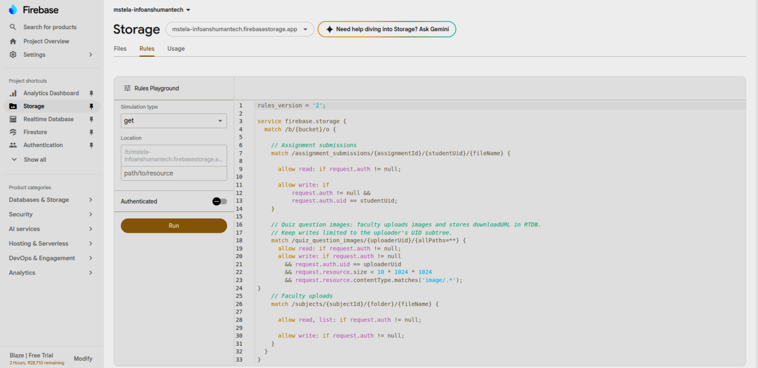
- No need to do anything in Analytics Dashboard keep it as is
- In firestore create anyone admin by doing below things:
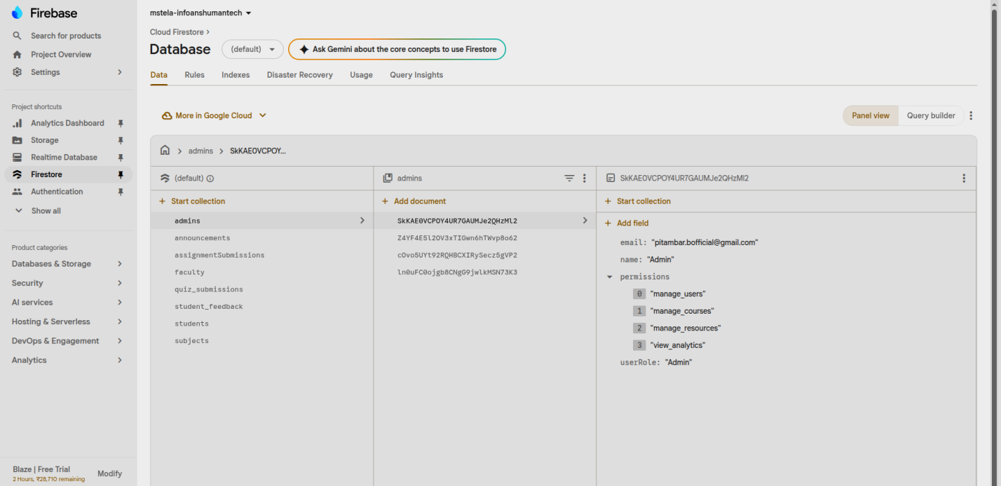
- In admins add document with id as any persons UID you can get this ID from Authentication tab , followed by email as string, name as string, permissions array and a userRole string
- If you don’t see admins in collection then first do step 3 and then check back later for this step of firestore

Step 3: Setup LMS website:-
- Clone the project locally by doing git clone or download zip file of website code from https://github.com/anshumaneducation/LMS_Anshumantech
- Now install below things on PC that are dependencies and packages required to run dart website and setup new firebase project:
- Git
- Firebase CLI
- FlutterFire CLI
- Vscode
- Flutter SDK
- Dart SDK
Verify the installations:
flutter --version
dart --version
node --version
firebase --version

Run Flutter's environment check:
flutter doctor
Resolve any critical issues reported by flutter doctor before continuing.
- Install Flutter Project Dependencies:
Open PowerShell/Terminal in the LMS project directory.
Make sure the current directory contains:
pubspec.yaml
Then run:
flutter pub get
Flutter projects use pubspec.yaml to define their dependencies, and flutter pub get installs/resolves those dependencies.

Step 4: Configure Firebase CLI :
Login to Firebase
- Check Firebase CLI:
firebase --version
- Login using the Google account that has access to the new Firebase project:
firebase login
A browser window will open for Google authentication.

Step 5: Configure FlutterFire
- Install FlutterFire CLI
Activate FlutterFire CLI:
dart pub global activate flutterfire_cli
On Windows, if the flutterfire command is not recognized, verify that the Dart Pub executable directory is present in PATH:
C:\Users\<YourUsername>\AppData\Local\Pub\Cache\bin
The FlutterFire setup guide also identifies this directory as the typical Windows Pub Cache executable location.
- Remove Existing Firebase Configuration
Before connecting the application to the new Firebase project, remove the existing Firebase project configuration:
Remove-Item -Path .firebaserc, firebase.json, lib/firebase_options.dart -ErrorAction SilentlyContinue
Do not delete the entire lib directory or other application source files.
- Configure the New Firebase Project
From the Flutter application directory containing pubspec.yaml, run:
dart pub global run flutterfire_cli:flutterfire configure
Select the new Firebase project when prompted.
Select the platforms required by the LMS application.
For the existing setup, select:
android
ios
web
FlutterFire will register/configure the required Firebase applications and generate:
lib/firebase_options.dart
This file contains the Firebase configuration used by the Flutter application.

Step 6: Run and Verify the LMS Website
- Run the application:
flutter run
For a web application, select the required browser/device or use:
flutter run -d chrome
- Verify that:
- The application starts successfully.
- Firebase initializes without errors.
- Login works using Email/Password.
- New user registration works if supported.
- Firestore data can be read.
- Firestore data can be written.
- Realtime Database can be read/written where required.
- Storage files can be uploaded/downloaded where required.
- Admin functionality works correctly.

Step 7: Now push this website to new GitHub repository make it public, in settings enable hosting, to add domain name use GoDaddy and use github ip addresses.

